# Truganina South NCR public engagement potential: For discussion

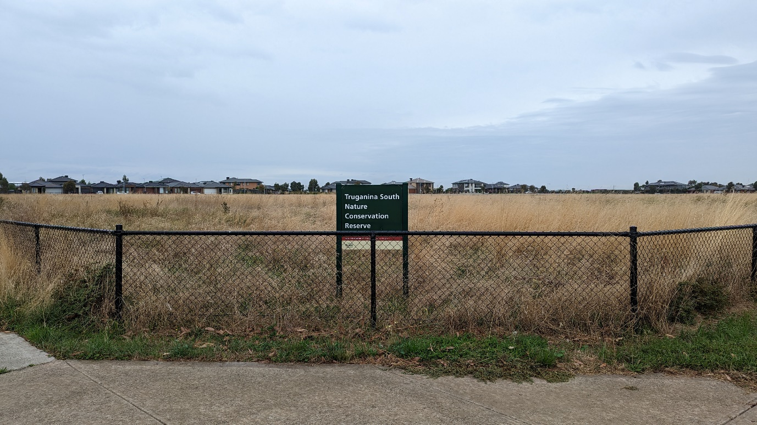

Contact:

Adrian Marshall

Facilitator

Grassy Plains Network

0413 757 173

[adrian@vnpa.org.au](mailto:adrian@vnpa.org.au)

grasyplains.net.au

## Summary

Truganina South is a major grassland in Wyndham City that has a strong residential context and a population that, for various historical reasons, has particularly negative attitudes to the grassland. Improvements to the presentation of the grassland are desperately needed, as are efforts to engage the surrounding community.

Showcase plantings that demonstrate the beauty of grasslands are important for the greater grassland conservation effort because otherwise all people see are poor degraded examples of grassland. We have to change the perception of grasslands. We can aim to leverage positive experiences to then further engage people with grasslands that may not immediately present with strong engagement qualities such as floral display.

Additional opportunities include: survey of attitudes, signage, litter clean-up activities, distribution of CaLD grassland videos currently in production, letterboxing, works within the Reserve (e.g. creating entrances for engagement), citizen science activities, and reworking road cross-sections during scheduled works.

If done well, a multi-year engagement process at Truganina South NCR using a range of actions would provide a good case study for what can be achieved. The learnings from such a project would have direct application across most of the grasslands in Melbourne’s north and west.

Given that funding may need to come from multiple sources over numerous years, it would be wise to document achievements well and build a good before/after evidence base to demonstrate success and allow peer-reviewed publication of results.

## Character

Trug South is a large (38.1 ha) grassland conservation area. Its presentation is generally poor. Existing signs are limited and old-fashioned. It is edged variously by arterial and major roads that divide it into six blocks, and by narrow residential streets often with only a footpath on the housing side of the road. Most of the Reserve is heavily weedy. There is no public access. Dohertys Drain runs along much of its northern edge presenting as a well-landscaped area, aesthetically pleasing to live beside, and where water birds are common. To the south, the residential areas have poor views, being presented by an inaccessible, weedy edge, often in-filled with mortared basalt stones of left weedy at an ankle-breaking angle.

The site slopes, so in places there is up to a 150cm or so height difference between the adjacent road and the grassland. Street tree planting on adjacent roads is often strong and provides good local character. There are many long views across the grassland and waterways.

The urban planning approach to the area has cut the site up, made movement awkward, and generally not made the most of what could have been a great local asset.

## Conservation values

Truganina South NCR is primarily reserved as part of the Melbourne Strategic Assessment for the conservation of Golden Sun Moth and Striped Legless Lizard. It is managed by Parks Victoria with funding from DEECA. As a grassland, it is generally not species-rich, though its population of *Stackhousia subterranea* puts on a good show. Parts have been previously cropped. Stony rises have the best floristic values.

It has a severe infestation of Serrated Tussock that has produced newsworthy seed storms. Chilean Needle-grass was accidentally introduced through an edge planting.

It is the site for two experiments: one on Serrated Tussock control, the other with plantings of Button Wrinklewort as an investigation into their genetics.

### Golden Sun Moth

Golden Sun Moth is listed as Critically Endangered under the EPBC Act. The Melbourne Strategic Assessment KPI for the GSM is that the five year mean proportion of monitoring sites occupied must remain above a baseline set by the first five years of survey. The GSM population is monitored to this end.

### Striped Legless Lizard

Striped Legless Lizard is listed as Vulnerable under the EPBC Act. The Melbourne Strategic Assessment KPI for the SLL is that evidence of Striped Legless Lizard is detected at least once in every five-year period at 100% of permanent monitoring plots (i.e. plots which have previously yielded detections). At Truganina South NCR, Striped Legless Lizard was detected in 2019.

## The community

Strong presence of CaLD communities, primarily speaking Indo-Aryan languages (e.g. Hindi, Punjabi), others speaking Chinese languages or Southeast Asian languages (e.g. Tagalog). The great majority also speak English well.

Some reports indicate residents were told by some real estate agents that Truganina South NCR would be parkland with playgrounds etc.

Anecdotally, residents are generally not pleased with the presence of the grassland. This feeling exacerbated by Serrated Tussock seed storms.

## Potential engagement approaches

### Before and after community survey

Engagement is a hard ask at Trug South because the residents have been misled by real estate agents, subjected to seed storms, the urban planning context is poor, and the reserve historically poorly managed and inaccessible.

Given the scale of the intervention needed to turn community attitudes around, some before and after assessments should be undertaken with other engagement actions. Funding will have to be provided over numerous years, and it is important to have data showing that positive change is occurring.

A survey of attitudes will need to be carefully crafted to allow good analysis of data to provide reputable evidence. It will need to consider how to communicate with the CaLD communities present. It will have to be delivered via time-consuming letterboxing or door-knocking. It should also be delivered online and via QR-code on local signage, newspapers and possibly via Council resources.

### Grasslands info kit, delivered to letterbox

Brochure talking about value of the Reserve and grasslands in general.

Most residents speak English well, which allows this product to be in English only.

### Signage and branding

The only signs present are old-fashioned Parks Victoria signs. New signage could take several forms and use QR codes to allow for deeper digital engagement.

**Interpretive** signs leveraging existing signage on waterways.

**Gateway** signage leveraging school sculptures

**Sculptural** objects to be viewed at speed by cars on adjacent arterials

**Pin marker** signage to highlight individual species.

### Plantings

There are numerous opportunities for plantings to enhance amenity. Factors to consider include: visibility, orientation (e.g. trees should not overshadow grassland), potential to scrape and sow, need to improve unsightly edge, pedestrian or cycle movement, speed of cars, type of road cross-section.

**Linear edge** plantings would be between roadway and Reserve where no footpath exists.

**Nature strip** plantings would be adjacent to Reserve where footpath does exist

**Street tree** plantings: Some locations lack street trees

**Corner** plantings: intersections offer higher visibility, and plantings here help identify place.

**Pocket** plantings: Some edges have room for plantings only in small pockets.

**Gateway** plantings: To highlight the extended nature of the Reserve and key major road locations

**Entry point** plantings: No public entry points yet exist, but if created they should be well-planted

### Walkways

The three walkways through the Reserve all offer good logical locations for combined plantings, artwork (e.g. on horizontal plain) and sculptural branding, signage etc.

There are plans in place to bridge Dohertys Drain at two of these locations. Those works would provide a good point of engagement and involvement.

### Potential engagement within the reserve

**Entry points**, with seating: There is currently no public access. This is a major barrier to public engagement. There must be areas where the public can be allowed in to sit and enjoy the open space. These could be curated with further internal fencing to discourage further access.

**Scrape and sow** within grassland: Highly weedy areas may be suitable for scrape and sow activities intended to create floral resources and strong visual effect

**Tubestock plantings** are another good option

### CaLD grassland videos

The Grassy Plains Network, with Parks Victoria Volunteer Innovation funding, is developing a series of grassland videos aimed at CaLD communities. It would be useful to target the distribution of these to adjacent residents through promotional letterboxing.

### Litter clean up

Always a good easy gateway to further nature engagement, several locations at trug South have minor dumping.

### Citizen science: Bugs of Trug South

Insects may be the best target of citizen science surveys because of the degraded nature of the grassland. The sounds of insects chirruping is one of the more positive engagement qualities of the Reserve.

### Reworked road cross sections when works timetabled

It would be good to take opportunistic advantage of any planned roadworks on the Trug South edge to make space for additional plantings, a Reserve-side footpath, and generally improve the residents experience.

### Linking projects to school adjacent (St Claire’s Catholic Primary School) and school nearby (Dohertys Creek P–9 College)

Two schools are close by, and both offer great potential for some sort of engagement.

## Other matters

### Contacting community

We will need a means of building an email list to simplify and cheapen communications to adjacent residents.

Initial contact will be through community groups, and perhaps through letterboxing. We can build a webpage and supply its URL and ask people to join etc.

Facebook allows geotargeted advertising, though it may not be very effective.