Geelong Strategic Assessment FAQ

Where are the Northern and Western Geelong Growth Areas
There are two growth Areas, totalling 6000 ha.
The Northern Geelong Growth Area is mostly farming land and ‘lifestyle’ properties on the escarpment.
The Western Geelong Growth Area includes the Batesford Quarry and Geelong Lime, the Moorabool River and Cowies Creek, as well as farming land and lifestyle properties. Not all the Western Geelong Growth Area is included in the Geelong Strategic Assessment, only the northernmost portion is.
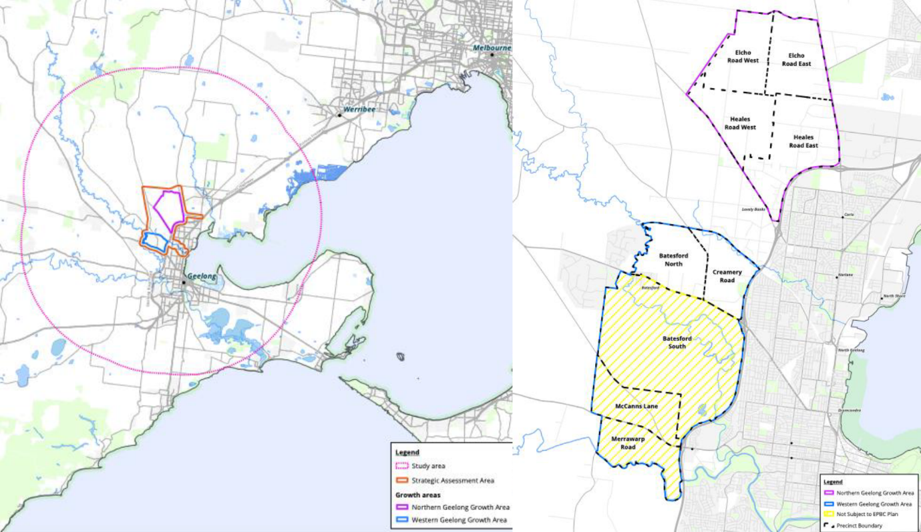

What conservation values are in the Northern and Western Geelong Growth Areas
A lot! There is almost 700 ha of Golden Sun Moth habitat and four separate populations of Striped Legless Lizard. There’s also lots of grassland, some categorised as Natural Temperate Grassland of the Victorian Volcanic Plain, the rest categorised as Western (Basalt) Plains Grassland or Plains Grassland. There are also Tussock Skink, and probably Fat-tailed Dunnarts (though they haven’t been surveyed for).
What is the Geelong Strategic Assessment?
It’s an agreement between the City of Greater Geelong and the Commonwealth that regulates how EPBC-listed communities and species are to be protected across the Northern and Western Geelong Growth Areas. The idea is that it looks at the landscape as a whole and makes strategic decisions about what to protect and what to allow to be cleared, rather than those decisions being fought over block by block, paddock by paddock. Sounds good on paper, but the Melbourne Strategic Assessment has been a disaster for the environment.
Why was the Melbourne Strategic Assessment so bad?
Here are thirty reasons, in no particular order.
- Poor survey, reliant on modelling and roadside assessments (looking over fence), and hampered by lack of access
- Future owners of Conservation Areas not known
- No oversight of private management of Conservation Areas
- Insufficient funding through levy
- Lack of upfront purchases of land for conservation
- Lack of interim management strategy for private land
- No oversight of Melbourne Strategic Assessment team
- No transparency about decision-making
- Initial land purchases have been “hardship” purchases of poor quality grassland, not good quality blocks
- No cultural heritage survey means no disturbance to soil allowed means fewer management options
- No all appropriate species monitored
- No monitoring of ecosystem health indicators
- Targets set are underwhelming
- No targets for restoration
- Funding model based on ten-year offsetting process, inappropriate for grasslands that need management in perpetuity
- Levy funds narrow set of management activities, excludes engagement
- Poor interface considerations, e.g. major roads, effects of lighting, industrial pollution
- Poor consideration of state and local species
- Big is better myth causes loss of small, biodiverse patches
- Land management agreements with private owners kicked down road to PSP process, meaning huge delays in ensuring protection of conservation values
- Perception at highest levels that “grasslands are solved” somehow
- No branding, engagement, visitor experience yet planned
- Lack of planning controls (e.g. ESOs)
- PSP process not meeting conservation needs
- Poor reporting
- Environment wears risk, developers get certainty
- No fire management strategy
- No research component
- No incorporating NGOs, Universities etc into management
- No Indigenous cultural training for staff / contractors
What is the timeline for the Geelong Strategic Assessment
A set of documents including plans for what areas are going to be conserved, what offset, as well as rules for governance and funding, are going to be released for public comment on 23 June this year. They are looking to have final approvals completed by the start of next year. After that it is all locked-in, and there will be a lot less opportunity to make any changes that benefit the environment.
What can I do?
Join us and together we will have a stronger voice. We plan to write to politicians, local members, Council, talk to journalists and spread the message through socials.
Who is currently in this alliance concerned about the Geelong Strategic Assessment?
The Grassy Plains Network
Batesford Fyansford and Stonehaven Landcare Group
Geelong Field Naturalists Club
Friends of the Bannockburn Bush
VVP Biosphere
Batesford Fyansford and Stonehaven Landcare Group
The Victorian National Parks Association
Cool Geelong
Parents for Climate Action Geelong - Bellarine – Surfcoast

